

TRANSCRIPT ENTRY WORKSHEET

This document is for your working purposes only. As part of the AUPT Application, you must complete the digital version and upload the PDF you receive in your email to the Auburn Graduate School application. This worksheet is a snapshot of the digital document to allow you to gather the needed information ahead of time.

Please carefully follow the instructions to complete these forms. For questions, please contact the program through email at dpt@auburn.edu.

Instructions:
This worksheet is designed to help you collect the needed information for your Transcript Entry Document (TED) before you fill out the official form. Each applicant must complete the five sections included in the Transcript Entry Document as part of the AUPT application. This document must be completed online. All coursework entries should match the information on your official transcripts. It is the applicant’s responsibility to ensure that all information provided is complete, accurate, and truthful.

[Page 1]: Background Information
Begin by answering the general information questions regarding:
- Applicant Information
- Residency
- Background

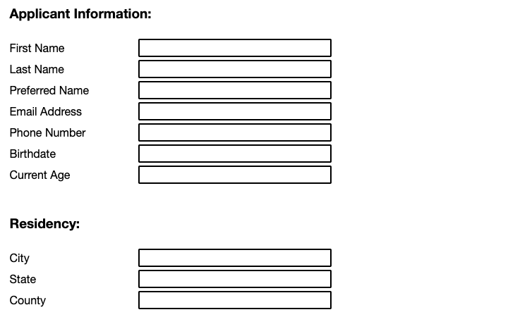
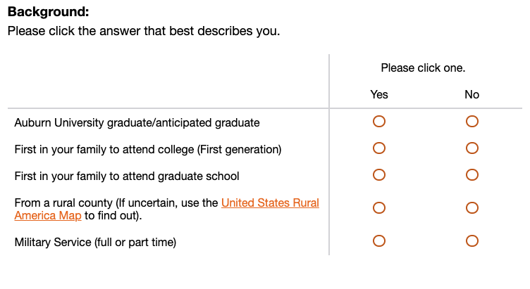

[Page 2]: Academic Information, History, and Overall GPA
- Type the requested academic information.
- Next, list each institution beyond high school that you have attended, including any dual enrollment, community colleges, undergraduate universities, and graduate schools. For each institution, include the institution name, degree level, semester and years started/ended, GPA hours earned and quality points. All this information can be found on your transcript from each institution you have attended. Only use the number of rows you need, leave the extra rows blank.
Institution Name | Degree Level  (Dual Enrollment, Associates, Bachelors, Graduate, Certificate, Transient) | Semester Started-Semester Ended  (Ex. Fall 2023-Spring 2027) | GPA Hours Earned | Quality Points Earned

Institution | Degree Level | GPA Hours | Quality Points
Auburn University | Bachelors | 77 | 287
Southern Union State Community College | Transient | 27 | 75
Calhoun Community College | Dual Enrollment | 6 | 24
Total |  | 110 | 386
- Overall GPA Calculator:
Note: This GPA will NOT be equal to your institutional GPA from your baccalaureate institution if you have additional credit elsewhere.
Total GPA Hours: Add up all the GPA Hours earned from ALL institutions/transcripts from above.
Total Quality Points: Add up all the Quality points from ALL institutions/transcripts from above.
Overall GPA: Divide the Total Quality Points by Total Credit Hours.
You can also use the GPA Calculator. Please make sure you include ALL grades from ALL institutions, including dual enrollment. Do NOT include AP credit or grades in this calculation.

Example:

Divide 386/110= 3.51 Overall GPA

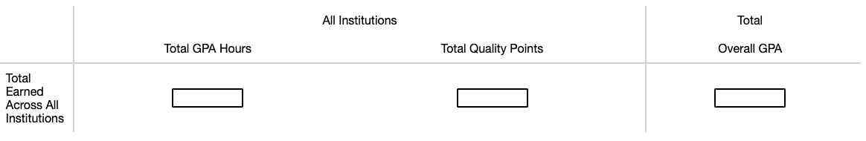

[Page 3]: Prerequisite Coursework Log
- To review details of AUPT required prerequisites, please click here.
- To determine how courses taken from other institutions equate to the prerequisites listed, please review the Transfer Equivalency Charts.
- At the time of application (July 1- September 30) all pre-requisites should be completed, in progress, or planned for a future academic semester.
- All but (8) eight hours of prerequisites must be completed by the end of Fall semester of the application year.
- Completion of all prerequisites and submission of official transcripts prior to the beginning of New Student Orientation (May) is required.
- For transfer and all other DPT admissions related inquiries, please email us at dpt@auburn.edu.
Instructions:
Institution Name: Indicate the institution where your course was taken NOT where it transferred.
Semester Taken: Indicate the semester you took the course Ex: Fall 2025
Course Code: Type the official course code for your institution. Ex: BIOL 1020
Attempt: Indicate which attempt for the course taken for the grade posted.
Credit Hours: Indicate the number of credit hours you received. If your course was a combination of both lecture and lab, please leave the lab space blank and adjust the credit hours for the lecture.
Grade Earned: Indicate which letter grade you received in the course. If you received credit as an AP course, please indicate. If you are currently taking the course, please indicate "In Progress". If you plan to take the course in a future semester, please indicate "Planned”.

Prerequisite Coursework Log Example:

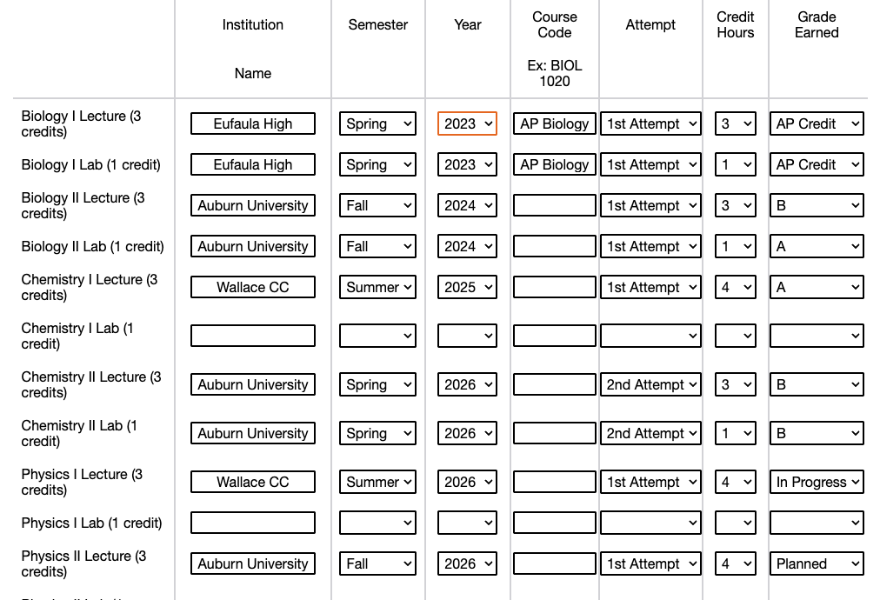
There is also a space available for you to include any additional information or explanations regarding your prerequisite coursework, if needed.
Subject Area | Prerequisite Courses | Institution Name | Semester | Year | Course Code | Attempt | Credit Hours | Grade Earned
Biology  (8 credits) | Introductory or General Biology I Lecture
Biology  (8 credits) | Introductory or General Biology I Lab
Biology  (8 credits) | Introductory or General Biology II Lecture
Biology  (8 credits) | Introductory or General Biology II Lab
Chemistry  (8 credits) | Introductory or General Chemistry I Lecture
Chemistry  (8 credits) | Introductory or General Chemistry I Lab
Chemistry  (8 credits) | Introductory or General Chemistry II Lecture
Chemistry  (8 credits) | Introductory or General Chemistry II Lab
Physics  (8 credits) | Introductory or General Physics I Lecture
Physics  (8 credits) | Introductory or General Physics I Lab
Physics  (8 credits) | Introductory or General Physics II Lecture
Physics  (8 credits) | Introductory or General Physics II Lab
Anatomy & Physiology  (8 credits) | Human or Mammalian Anatomy Lecture
Anatomy & Physiology  (8 credits) | Human or Mammalian Anatomy Lab
Anatomy & Physiology  (8 credits) | Human or Mammalian Physiology Lecture
Anatomy & Physiology  (8 credits) | Human or Mammalian Physiology Lab
Biomechanics  (3 credits) | Biomechanics/Analysis of Human Movement
Terminology  (2-3 credits) | Medical Terminology
Psychology  (3 credits) | Introductory or General Psychology
Math  (3 credits) | Introductory or Applied/General Statistics
Communication  (3 credits) | Technical Writing and/or Communication

[Page 4]: Recommended Additional Coursework Log
List any additional recommended course you have completed. These courses are not required but are highly recommended prerequisites that will contribute to an applicant’s preparation for the Doctor of Physical Therapy program.

Complete this form by following the same instructions used to fill out the “Prerequisite Coursework Log.” If you do not plan to take a course listed on this log, please select, “Not Taking” for the “Grade Earned”.

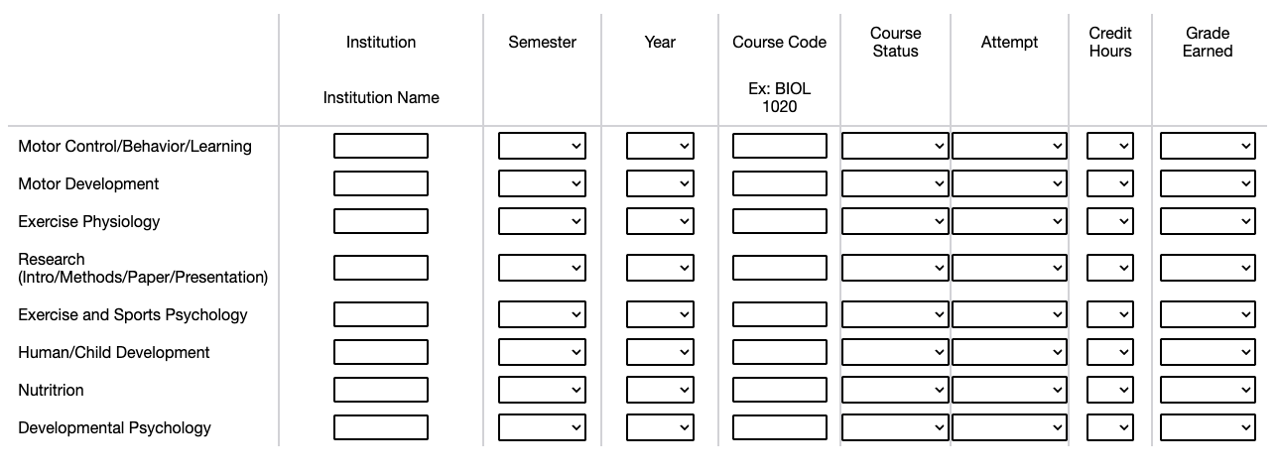

[Page 5]: Last 60 Hours Coursework Log
List your undergraduate and/or graduate coursework in reverse chronological order, starting with your most recent academic semester and working backwards. Continue listing courses until you have accumulated exactly 60 credit hours.

- Do not include courses that are still in progress or planned at the time of application.
- Only include courses graded with letter grades.
- AP Credit, Pass/Fail, and Satisfactory/Unsatisfactory courses should not be listed in this calculation.

For each course, provide the course code, course title, number of credit hours, grade received, semester and year taken, and the institution where the course was completed. Once you reach 60 credit hours, stop listing courses, and leave any additional rows blank.
Institution Name | Course Code | Course Title | Semester and Year | Credit Hours | Grade Earned

[Page 6] Transcript Verification and Applicant Certification

Sign and date this form to confirm accuracy and authenticity of your academic information.

- Make sure you sign this page with your mouse or digital signature.
- Type your full name and date of submission.

The Next Forward Arrow will submit your Transcript Entry Document.
DO NOT advance until you have thoroughly checked your entries. If you have any questions, please contact dpt@auburn.edu before you submit.

You will receive a “Thank you for completing the Transcript Entry Document portion….”
Transcript Entry Document (TED) Submission Guidelines:
- Fully complete the form before submission.
- Check your email for verification that the form is complete. (If an email is not received in 10 minutes, please return to the form to ensure you submitted.)
- In the verification email, there will be a link to a PDF document. Please download this document and save it as a pdf using the following format: LastName_FirstName_TED. (Example file name: Smith_Jane_TED.pdf)
- Upload the named PDF through the Auburn University Graduate School Application as part of your application packet.
AUPT Application Checklist:
Submit your application to Auburn University Graduate School. Please include the following items:
- Official transcripts from all institutions you have attended, including dual enrollment and transient courses. These will be sent directly from the institution. If you are currently enrolled, we will accept an unofficial from that institution with an official sent upon graduation/completion.
- Transcript Entry Document. Fill out the form online. A .pdf of the form will be emailed to you. Please save the .pdf as “Last Name, First Name” and upload to your application.
- Observation Hours Verification Forms (minimum 100 hours)
- Personal Statement/Letter of Intent (2 page maximum)
- One-page Essay regarding the current challenges facing the physical therapy profession (500-word limit)
- Resume (2 page maximum)
- Three letters of recommendation (recommender will upload directly)
    - 2 from US licensed physical therapist who supervised the applicant
    - 1 from a professor in an upper-level class in the applicant’s major
- Pay $200 application fee (non-refunable)
Additional Resources:
- For admission criteria and a list of prerequisite courses, visit the “Prospective Student” page on the Auburn University Physical Therapy website.
- Review the Transfer Equivalency Charts to see how courses from other institutions compare to Auburn University courses.
- For questions, contact the program through email at dpt@auburn.edu.

